Project V

Neil P. Parmar

Dept. of Electrical Engineering and Computer Science

Oregon State University, Corvallis, USA

parmarn@oregonstate.edu

1. Introduction

The particular project has two parts where the first part involves to test the array multiplication, SIMD and non-SIMD. The second part involves to test the array multiplication and reduction, with SIMD and non-SIMD.

1. System Configurations & Load

This project was implemented using the flip server at OSU on-campus computer labs which has about 24 CPU cores. Fig 1 below shows the CPU average load for 1, 5 and 15 minutes to be 1.46, 1.35 and 1.45 respectively.



Fig 1. System configurations – System Load

1. Implementation Specifications

The implementation code is mainly separated into SIMD and non-SIMD code respectively. The output performance calculated for the particular can be found in the Output.txt file. Moreover, the code generates its results using the test.sh script for the non-SIMD code. SIMD was tested manually. Both these codes were tested under varying array size from 10K to 10M. Under the SIMD folder, the code for SIMD is contained within the arraymult.cpp, simd.p5.o, simd.p5.h with makefile, and the non-SIMD folder contains the main implementation files under the arraymult.cpp.

1. Performance and Speedup
2. Multiplication Average Performance



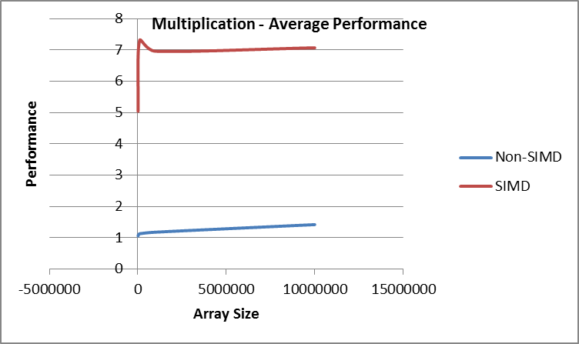

Fig 2. Multiplication – Average Performance

The Table I above shows the performance for the Non-SIMD and SIMD, where the performance is relatively constant for Non-SIMD. However, the performance for SIMD considerably increases until a particular array size, in the particular scenario an array size of 106 shows a considerable increase. However, the performance slightly decreases and remains almost constant for an array size of 107. The particular has also been replicated in the graph. Note, the performance here is measured as MegaNumTries/second.

The graph for speedup with respect to ratio of SIMD and Non-SIMD for the particular is shown in the image below. Here the speedup considerably increases as for array size lower than 105, however the speedup is slowly affected for all the later array sizes.

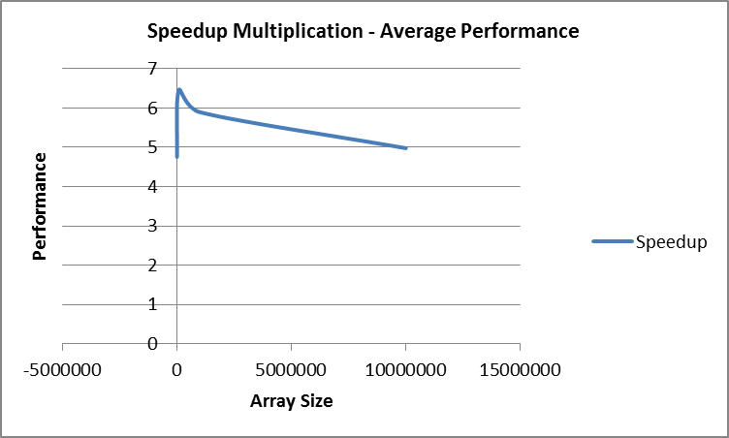

Fig 3. Speedup Multiplication

1. reduction Average Performance



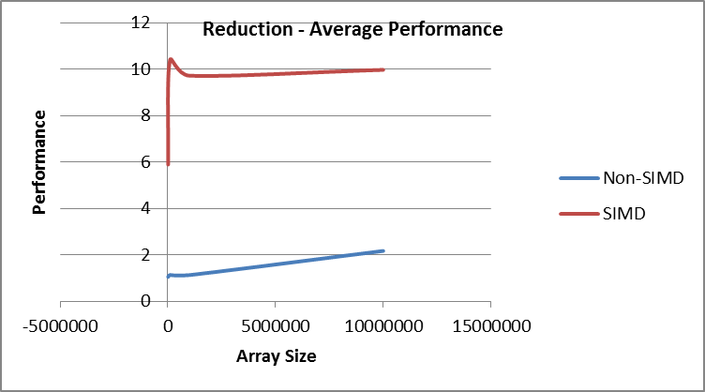

Fig 4. Reduction – Average Performance

The Table II above shows the reduction average performance for increasing array size. Here the performance behavior for SIMD is similar to that of multiplication. However, the non-SIMD array size shows a considerable increase with the increased number of arraysize.

The speedup for the particular has been plotted in the figure below. Here, a considerable good speedup is observed for all the lower arraysize, however with the increase in the arraysize the speedup considerably decreases.

However, for both multiplication and reduction, the speedup observed is around 5.0.

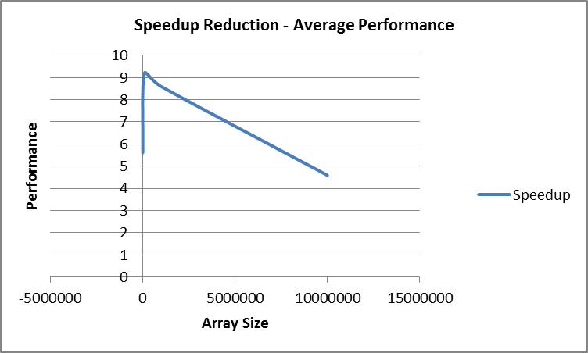

Fig 5. Speedup Reduction

1. multiplication Peak Performance



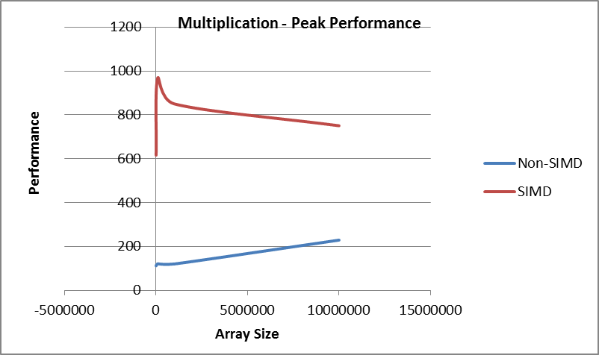

Fig 6. Multiplication – Peak Performance

Table III above and the graph represents the Peak performance which is observed at the array size of 105 and 106 respectively of 120.95 for Non-SIMD and 968.9 for SIMD. Note, the performance is measured here MegaNUMs/Sec. The graphical representation for the peak performance represents the similar performance observed with average performance. However, the performance of SIMD continues to degrade, whereas Non-SIMD steadily increases.

1. reduction Peak Performance



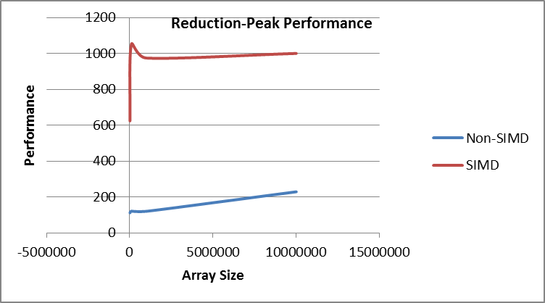

Fig 7. Reduction – Peak Performance

Table IV above and the graph represents the Peak performance where the performance for Non-SIMD becomes constant for Non-SIMD, however the performance is observed to slowly increase for SIMD. Note, the performance is measured here MegaNUMs/Sec as well. The graphical representation for the peak performance represents the similar performance observed with average performance in reduction.